Michael Wittmann
9
MILITARY

NONE
AIR POWER
N/A

RESOURCES
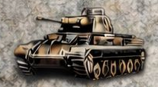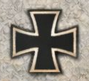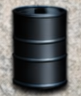
101st Tiger Bn* Gain 2 Lose 2
*available to deploy immediately
ORDERS: 3 Actions

Michael Wittmann (April 22, 1914 – August 8, 1944) was a German Waffen-SS tank commander. Wittmann is most famous for his ambush of elements of the British 7th Armoured Division, during the Battle of Villers-Bocage on 13 June 1944. While in command of a single Tiger he destroyed up to 14 tanks and 15 personnel carriers along with 2 antitank guns in the space of 15 minutes.

